Front End Engineering-II

Project Report
Semester-IV (Batch-2022)

PROJECT TITLE:
COUNTDOWN TIMER



Supervised By: Submitted By:
Raveesh Samkaria Shivansh Rana (2210990831) G-13

Department of Computer Science and Engineering
Chitkara University Institute of Engineering & Technology,
Chitkara University, Punjab

Abstract:
The Countdown Timer project aims to provide a straightforward and effective tool for creating countdowns for various purposes, such as events, deadlines, or reminders. In a world where time management is crucial, individuals often seek accessible methods to track and organize their schedules. This project focuses on delivering a user-friendly web-based timer that allows users to set custom countdowns quickly and accurately.
The timer emphasizes intuitive input fields and clear output to enhance user experience. Currently, this project utilizes HTML, CSS, BOOTSTRAP and JAVASCRIPT to achieve its functionality. The key features include:
Input Fields:
Users can input their desired countdown duration, specifying hours, minutes, and seconds, offering flexibility and convenience in setting timers for different purposes.
Countdown Display:
The timer displays the remaining time dynamically, updating in real-time as the countdown progresses, providing users with immediate feedback on their time remaining.
Customization Options:
Users have the ability to customize the appearance and behaviour of the countdown timer, including choosing different styles, themes, and sound effects to suit their preferences.
Responsive Design:
The timer is designed to be responsive across various devices, ensuring accessibility for users browsing from desktops, tablets, and smartphones, enabling them to manage their time effectively regardless of the device they're using.
In conclusion, the Countdown Timer project offers a convenient solution for individuals to manage their schedules and stay organized. With its user-centric design and customizable features, the timer empowers users to stay productive and efficient in today's fast-paced world.

CONTENTS:

S. no. | Sections | Page no. | Remarks
1 | Introduction | 4-5
2 | Problem definitions and requirements | 6
3 | Proposed design/Methodology | 7-9
4 | Results | 10-35
5 | References | 36

1. Introduction:
In the domain of time management and productivity, the Countdown Timer project stands as a crucial tool for individuals striving to organize and optimize their schedules effectively. With a focus on simplicity and accuracy, this project endeavours to meet the needs of those navigating the intricacies of time tracking and deadline management. In an age where efficiency and productivity are highly valued, the Countdown Timer offers a convenient solution for creating customized countdowns for various purposes. Through its intuitive interface and dynamic functionality, this timer seeks to empower users to stay on top of their tasks and achieve their goals efficiently.
1.2. Background:
As society's emphasis on efficiency and time management continues to increase, individuals are turning to digital tools for assistance in managing their schedules effectively. Countdown timers serve as valuable aids in tracking deadlines, events, and reminders. Recognizing the importance of accessible and accurate countdown functionalities, the Countdown Timer project emerges to fulfill this need. Leveraging the simplicity of HTML, CSS, Bootstrap, and JavaScript, this project provides users with an intuitive platform to set custom countdowns and monitor their progress in real-time. By embracing responsive design principles, the timer ensures usability across a range of devices, catering to the diverse needs of modern users.
1.3. Objectives:
Through the Countdown Timer project, our primary objectives revolve around empowering individuals to take command of their time management endeavours by offering a straightforward and efficient tool for creating countdowns. By delivering a user-friendly interface and precise countdown functionalities, we aim to facilitate better decision-making and foster productivity. Our focus on intuitive design, responsive features, and accessibility underscores our commitment to delivering a seamless user experience for individuals seeking to optimize their schedules. With customizable options and alert notifications, our goal is to enhance user engagement and promote efficient time utilization. Ultimately, we envision the Countdown Timer as a valuable resource that empowers users to stay organized, meet deadlines, and accomplish tasks effectively.
1.4. Significance:
The significance of the Countdown Timer project lies in its ability to address a fundamental need within the realm of time management and productivity, empowering individuals to make the most of their time. In an era where efficiency is paramount and individuals seek tools for effective schedule management, this project offers a valuable solution for creating and tracking countdowns. By providing a user-friendly interface, precise countdown functionalities, and customizable options, the Countdown Timer facilitates greater control over time utilization and encourages users to stay focused on their goals. As individuals strive to optimize their productivity and meet deadlines efficiently, the Countdown Timer project emerges as a valuable asset, enabling users to stay organized, manage their schedules effectively, and achieve their objectives.

- Problem definition and requirements:
In response to the growing demand for user-friendly online tools tailored to countdown management, there's a clear need for a comprehensive Countdown Timer project. Current solutions often lack the customization options, intuitive interfaces, and seamless integration necessary to meet the diverse needs of users. Thus, there's a demand for a timer that prioritizes simplicity, accuracy, and versatility to empower individuals in managing their time effectively.
  - Software Requirements:
Text editor for web development (e.g., Sublime Text, Visual Studio Code)
Web development frameworks (e.g., Bootstrap, Foundation) for responsive design
Image editing software (e.g., Adobe Photoshop, GIMP) for creating custom graphics
Version control system (e.g., Git) for collaborative development and tracking changes
  - Hardware Requirements:
Personal computer or laptop capable of running web development software efficiently
High-resolution display for accurate visualization and design refinement
  - Datasets:
Countdown duration dataset: Includes algorithms and formulas for precise countdown calculations based on user input.
Sample data for testing: Simulated countdown scenarios to validate the timer's functionality and accuracy across different time intervals.
These datasets will enable developers to build and refine the Countdown Timer project, ensuring accurate countdowns and a seamless user experience. Additionally, the sample data will facilitate testing and optimization of the timer's performance across various devices and screen sizes, catering to the diverse needs of users seeking to manage their time effectively.

- Proposed Design/Methodology:

  - Schematic Diagram:
The Countdown Timer project adopts a modular design approach to ensure flexibility and scalability. The schematic diagram illustrates the architecture of the project, highlighting the key components and their interactions.
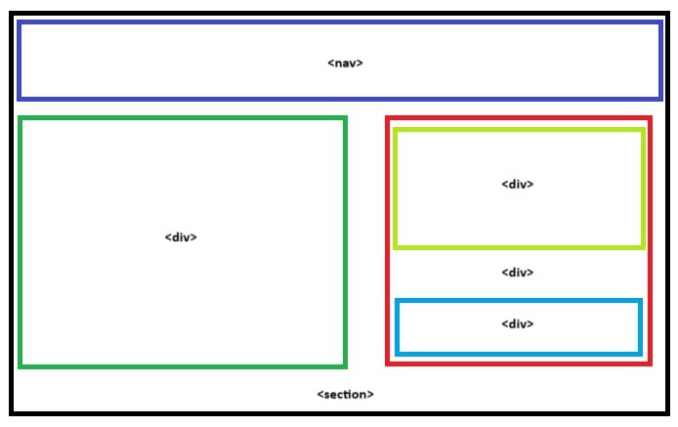

Figure 3.1 - Schematic diagram

  - File Structure:
The project is organized into several directories and files to maintain clarity and facilitate efficient development. The file structure includes the following main components:
countdown-timer/
│
├── css/
│ └── main.css # Cascading style sheets (CSS) files for styling the countdown timer.
│
├── images/
│ └── [copied address from browser] # Stores any necessary images or visual assets.
│
├── main.html # Main HTML file serving as the interface for the countdown timer.
└─
─ README.md # Markdown file providing documentation and instructions for developers.

  - Algorithms used:
The Countdown Timer project primarily leverages front-end web development technologies such as HTML, CSS, JavaScript, and possibly Bootstrap for styling. While these technologies do not inherently involve complex algorithms, certain algorithms may be employed for specific functionalities, such as:
Countdown Calculation Algorithm: Utilizes JavaScript functions to calculate the remaining time based on the user's input of countdown duration.
Event Handling Algorithm: Employs JavaScript event listeners to handle user interactions such as starting, pausing, and resetting the countdown timer.
Alert Notification Algorithm: Utilizes JavaScript methods to trigger alert notifications when the countdown reaches zero.
These algorithms play a crucial role in enhancing the functionality and accuracy of the countdown timer, contributing to its effectiveness in helping users manage their time efficiently.

- Results:

  - Screenshots:
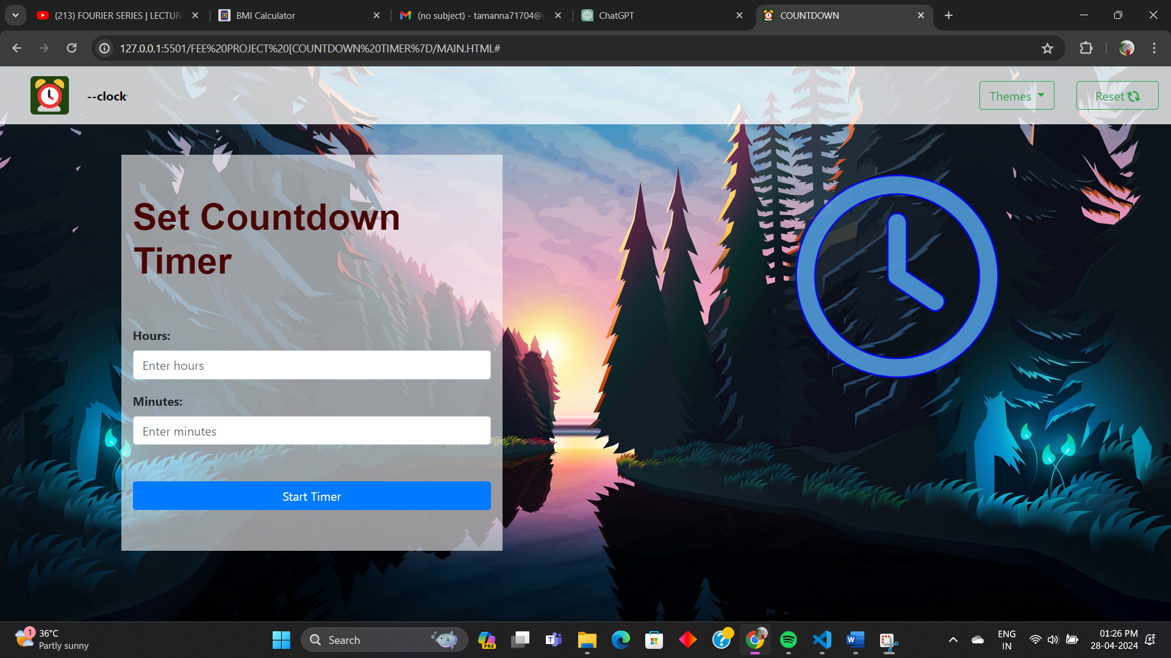
Figure 4.1 - Screenshot 1
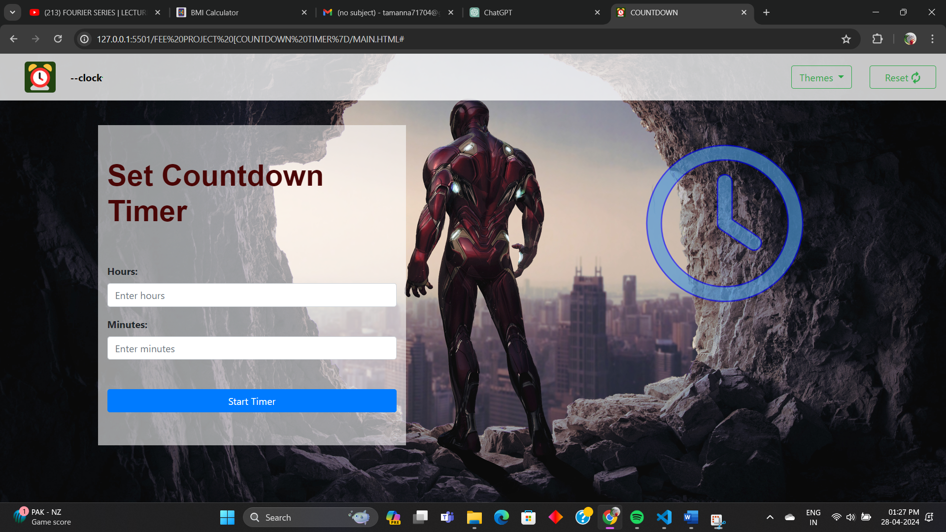
Figure 4.1 - Screenshot 2

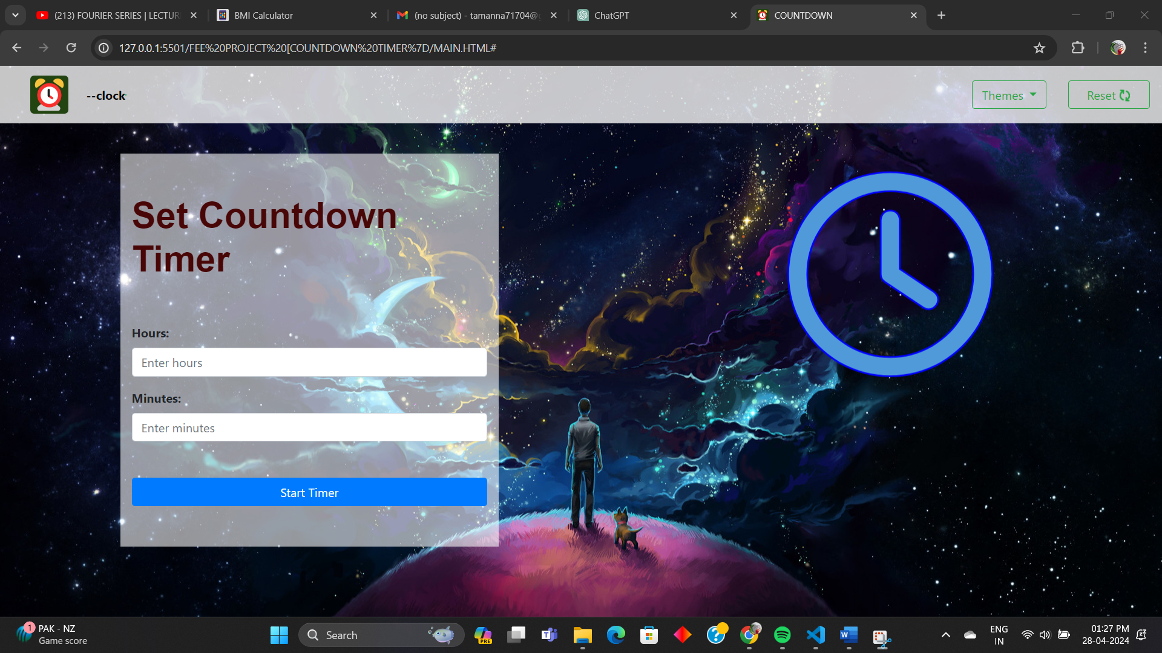
Figure 4.1 - Screenshot 3

  - Metrics:

In evaluating the performance and effectiveness of the Countdown Timer project, the following metrics were considered:
Timer Accuracy:
Evaluation of the timer's accuracy in counting down to the specified duration, ensuring precise time management.
Responsiveness:
Assessment of the timer's responsiveness across various devices and screen sizes, ensuring a seamless user experience.
User Interaction:
Metrics related to user engagement, such as the number of interactions with the timer, session duration, and frequency of use.
Customization Usage:
Analysis of user engagement with customization options such as theme selection, sound effects, and display preferences.
Error Handling:
Monitoring of errors or issues encountered by users during the usage of the timer, with a focus on identifying and resolving any technical glitches.
User Satisfaction:
Feedback from users regarding the usability, clarity of display, and overall satisfaction with the countdown timer interface.
These metrics provide valuable insights into the performance, user experience, and effectiveness of the Countdown Timer project, enabling continuous improvement and optimization to better serve the needs of users seeking to manage their time effectively.

  - HTML Code:
- <!DOCTYPE html>
- <html lang="en">

- <head>
- <meta charset="UTF-8">
- <meta name="viewport" content="width=device-width, initial-scale=1.0">
- <title>COUNTDOWN</title>
- <link rel="stylesheet" href="main.css">
- <link rel="stylesheet" href="https://cdnjs.cloudflare.com/ajax/libs/font-awesome/6.5.2/css/all.min.css">
- <link href="https://cdn.jsdelivr.net/npm/bootstrap@5.3.3/dist/css/bootstrap.min.css" rel="stylesheet"
- integrity="sha384-QWTKZyjpPEjISv5WaRU9OFeRpok6YctnYmDr5pNlyT2bRjXh0JMhjY6hW+ALEwIH" crossorigin="anonymous">
- <script src="https://cdn.jsdelivr.net/npm/bootstrap@5.3.3/dist/js/bootstrap.bundle.min.js"
- integrity="sha384-YvpcrYf0tY3lHB60NNkmXc5s9fDVZLESaAA55NDzOxhy9GkcIdslK1eN7N6jIeHz"
- crossorigin="anonymous"></script>
- <link rel="shortcut icon" type="image/x-icon" href="android-chrome-192x192.png">
- <script src="main.js"></script>
- <script src="https://code.jquery.com/jquery-3.5.1.slim.min.js"></script>
- <script src="https://cdn.jsdelivr.net/npm/@popperjs/core@2.5.4/dist/umd/popper.min.js"></script>
- <script src="https://stackpath.bootstrapcdn.com/bootstrap/4.5.2/js/bootstrap.min.js"></script>
- <link href="https://stackpath.bootstrapcdn.com/bootstrap/4.5.2/css/bootstrap.min.css" rel="stylesheet">
- <script src="https://cdnjs.cloudflare.com/ajax/libs/jquery/3.6.0/jquery.min.js"></script>
- <script src="https://stackpath.bootstrapcdn.com/bootstrap/5.1.3/js/bootstrap.bundle.min.js"></script>
- </head>

- <body class="theme-anime">
- <nav class="navbar navbar-expand-lg">
- <a class="navbar-brand mx-4" href="#"><img src="android-chrome-192x192.png" width="50px" height="50px"></a><b
- style="color:white;"><span style="color:black;">--clock</span></b>
- <ul class="navbar-nav me-auto mb-2 mb-lg-0 border border-success">
- </ul>
- <div class="dropdown">
- <button class="btn btn-tertiary dropdown-toggle border border-success mx-4 btn-outline-success" type="button"
- data-bs-toggle="dropdown" aria-expanded="false">
- Themes
- </button>
- <ul class="dropdown-menu" aria-labelledby="dropdownMenuButton">
- <li><a class="dropdown-item" href="#" onclick="changeTheme('anime')">Marvel</a></li>
- <li><a class="dropdown-item" href="#" onclick="changeTheme('space')">Space</a></li>
- <li><a class="dropdown-item" href="#" onclick="changeTheme('nature')">Nature</a></li>
- </ul>
- <button type="button" value="Relod Page" onclick="window.location.href=window.location.href"
- class="btn btn btn-tertiary border border-success btn-outline-success px-4">Reset <i
- class="fa-solid fa-arrows-rotate fa-spin"></i></button>
- </div>
- </nav>
- <section class="main">
- <div class="container1">
- <div class="container">
- <h5 class="heading-m py-5" style="color: rgb(73, 6, 6); font-family:sans-serif;font-size:3rem;"><b>Set Countdown Timer</b></h5>
- <div class="form-group">
- <label for="hours"><b>Hours:</b></label>
- <input type="number" class="form-control" id="hours" placeholder="Enter hours">
- </div>
- <div class="form-group">
- <label for="minutes"><b>Minutes:</b></label>
- <input type="number" class="form-control" id="minutes" placeholder="Enter minutes">
- </div>
- <button class="btn btn-primary btn-block my-5" onclick="startTimer()">Start Timer</button>
- </div>
- </div>
- <div class="clock">
- <div id="end" class="glow-clock">
- <i class="fa-regular fa-clock b fa-beat-fade" id="img1"></i>
- <i class="fa-regular fa-clock b fa-shake" id="img2"></i>
- <i class="fa-regular fa-clock b fa-spin fa-spin-reverse " id="img3"></i>
- </div>
- <div class="row justify-content-center">
- <div class="row1 timer-container">
- <h2 id="timer"></h2>
- </div>
- </div>
- </div>
- </section>
- </body>

- </html>

- .b{
- font-size: 15rem;
- -webkit-text-stroke: 2px;
- -webkit-text-stroke-color: blue;
- color: rgb(80, 154, 218);

- }
- .theme-anime{
- background-image: url('http://hdqwalls.com/download/iron-man-avengers-endgame-4k-2019-og-3840x2400.jpg');
- background-position: center;
- background-repeat: no-repeat;
- background-size: cover;
- }
- .navbar{
- background-color: #ffffffc6;
- }
- .glow-clock{
- font-size: 15rem;
- display: flex;
- align-items: center;
- justify-content: center;
- width: 400px;

- }
- .clock{
- display: flex;
- flex-direction: column;
- justify-content: space-around;
- align-items: center;
- }
- .timer-container {
- text-align: center;
- }

- #timer{
- font-weight: 600;
- font-size: 5rem;
- font-family:sans-serif;
- /* display: flex; */
- justify-content: center;
- display: inline;
- -webkit-text-stroke: 2px;
- -webkit-text-stroke-color: blue;
- color: rgb(80, 154, 218);

- }
- .main{
- display: flex;
- flex-wrap: wrap;
- justify-content: space-around;

- }
- .container1{
- width:500px;
- height: 520px;
- display: flex;
- flex-wrap: wrap;
- justify-content: left;
- align-items: center;
- background-color: #ffffff95;
- margin-top: 40px;
- }
- #img2{
- display: none;
- }
- #img3{
- display: none;
- }
- body {
- transition: background-color 0.3s ease;
- }
- /* .theme-anime {
- background-image: url('https://wallpapercave.com/wp/wp9737739.png');
- background-position: center;
- background-repeat: no-repeat;
- background-size: cover;

- } */
- .theme-space {
- background-image: url('https://wallpapercave.com/wp/wp7051639.jpg');
- background-position: center;
- background-repeat: no-repeat;
- background-size: cover;
- }
- .theme-nature {
- background-image: url('https://wallpaperbat.com/img/342204-download-wallpaper-3840x2160-river-forest-sunset-landscape-art.jpg');
- background-position: center;
- background-repeat: no-repeat;
- background-size: cover;
- }

  - Javascript code:
- let countdown;
- function startTimer() {
- const hoursInput = document.getElementById('hours').value;
- const minutesInput = document.getElementById('minutes').value;
- const timerDisplay = document.getElementById('timer');
- let totalSeconds = parseInt(hoursInput) * 3600 + parseInt(minutesInput) * 60;

- function displayTimeLeft(totalSeconds) {
- const hours = Math.floor(totalSeconds/3600);
- const minutes = Math.floor((totalSeconds % 3600)/60);
- const seconds = totalSeconds % 60;
- const display = `${hours}:${minutes < 10 ? '0' : ''}${minutes}:${seconds < 10 ? '0' : ''}${seconds}`;
- timerDisplay.textContent = display;
- }

- function timer(totalSeconds) {
- clearInterval(countdown);
- const now = Date.now();
- const then = now + (totalSeconds * 1000);
- displayTimeLeft(totalSeconds);

- countdown = setInterval(() => {
- const secondsLeft = Math.round((then - Date.now()) / 1000);

- if(secondsLeft>0){
- document.getElementById('img1').style.display='none';
- document.getElementById('img2').style.display='none';
- document.getElementById('img3').style.display='block';

- }
- if (secondsLeft <= 0) {
- clearInterval(countdown);
- timerDisplay.textContent = 'END';
- document.getElementById('img1').style.display='none';
- document.getElementById('img2').style.display='block';
- document.getElementById('img3').style.display='none';
- return;
- }

- displayTimeLeft(secondsLeft);
- }, 1000);

- }

- timer(totalSeconds);
- }

- function changeTheme(theme) {
- $('body').removeClass('theme-anime theme-space theme-nature');

- $('body').addClass('theme-' + theme);
- }

- References:

Font Awesome Icons: Employed for adding scalable vector icons to the user interface. Citation: Font Awesome. (n.d.). Retrieved from https://fontawesome.com/
Google Fonts: Utilized for incorporating custom fonts into the design. Citation: Google Fonts. (n.d.). Retrieved from https://fonts.google.com/
Unsplash: Source of high-quality, royalty-free images used in the project. Citation: Unsplash. (n.d.). Retrieved from https://unsplash.com/
Bootstrap: website utilizes Bootstrap for responsive design and pre-styled components, enhancing its appearance and functionality from https://getbootstrap.com/

These references provide valuable resources and tools that were utilized in the development of the Countdown Timer project. Proper citation ensures acknowledgment of the contributions and adherence to best practices in web development.

